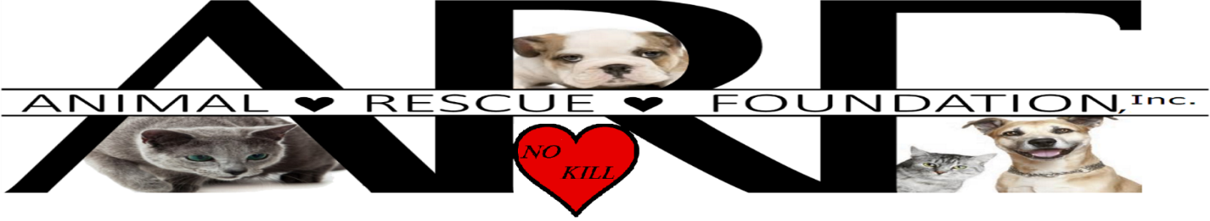
Mission: Together we enhance the lives of animals in need.
Vision: All animals have a safe and secure home.

VOLUNTEER APPLICATION
Thank you for your interest in ARF! We need the participation of volunteers to help us fulfill our mission.

Name: __________________________________________________________________________________________________
Address: ________________________________________________________________________________________________
City: ____________________________ State: __________ Zip: _____________ Preferred phone#: ________________________
Email address: ____________________________________________________________________________________________
Employer: ______________________________________ Position: _________________________________________________
Do you have any special talents, skills or previous volunteer experience that you think would benefit ARF?____________________
________________________________________________________________________________________________________

Which of our programs would you like to know more about or interest you as a volunteer?
_____ Fundraising (please specify help at events or planning committee or both) ___________________________________
_____ Foster care – please specify (cats, kittens, dogs, puppies) _______________________________________________
_____ Animal care at ARF barn for pets being temporarily held until foster care or transfer occurs
_____ TNVR clinics (Trap/Neuter/Vaccinate/Return) - please specify help with calling to organize clinic, help checking out & checking in traps, help checking in & feeding feral cats, help at the clinic _________________________________________
_____ Pet Food Pantry
_____ Baking or making craft items for fundraisers
_____ Transferring animals to partner shelters
_____ Clerical, administration, Board of Directors
_____ Public Relations, Marketing, Education (please specify) _________________________________________________
_____ Social media, website

Please circle days available: Mon Tues Wed Thurs Fri Sat Sun Notes: ______________________________________
Times available on what days of the week: Morning ________________Afternoon _______________ Evening ________________
Any physical limitations and/or lifting restrictions? ________________________________________________________________
In case of emergency, contact name and phone number:___________________________________________________________

As a volunteer I agree to abide by the policies and procedures of ARF. I understand that I will be volunteering at my own risk and that ARF, ARF’s Board Members, Volunteers and Affiliates cannot assume any responsibility for any liability for any accident, injury or health problem which may arise from any volunteer work I perform for ARF. I agree that all work performed for ARF is on a volunteer basis.

Signature: __________________________________________Printed Name: ______________________________________
If under the age of 18, printed name of Parent/Legal Guardian:___________________________________________________ Parent/Legal Guardian Signature: _________________________________________________________________________
Date: ________________________________

